**Project Identification**

|  |  |
| --- | --- |
| **Project:** | T15 – RepairBud Car Servicing Application |
| **Prepared By:** | Aslm, Elha, Ardm, Patrick |
| **Document Version:** | Version 1.0 |
| **Published Date:** | September 30th 2019 |

**Contributors**

The following individuals contributed to this document.

| **Name** | **Title** |
| --- | --- |
| Artem Dryevov | Developer |
| Patrick Parreno | Developer |
| Aslm Patel | Developer |
| Elham Salmanian | Developer |

**Distribution**

This document is distributed to all the following people.

| **Name** | **Title** |
| --- | --- |
| Artem Dryevov | Developer |
| Patrick Parreno | Developer |
| Aslm Patel | Developer |
| Elham Salmanian | Developer |

**Referenced Documents**

This document refers to the following materials

|  |  |  |  |  |
| --- | --- | --- | --- | --- |
| **Version number** | **Title** | **Author** | **Date** | **Source / Location** |
| N/A | N/A | N/A | N/A | N/A |
|  |  |  |  |  |
|  |  |  |  |  |

**Revision History**

|  |  |  |  |
| --- | --- | --- | --- |
| **Version Number** | **Revision Date** | **Summary of Changes** | **Modified by** |
| 1.0 | *09/26/2019* | Gathering and noting down possible Areas of scope and mocking up a business context Diagram | Artem Dryevov  Patrick Parreno  Aslm Patel  Elham Salmanian |
| 1.1 | *09/28/2019* | Detailed Scope fields filled out and noting down possible high level Scope Statements | Artem Dryevov  Patrick Parreno  Aslm Patel  Elham Salmanian |
| 1.2 | 09/29/2019 | Finalized all scope and high level scope statements, along with edited business context Diagram | Artem Dryevov  Patrick Parreno  Aslm Patel  Elham Salmanian |

[Note: It is recommended that drafts be numbered 0.1 to 0.9, and that the first approved version be numbered 1.0. Thereafter, new version numbers will depend upon changes: 1.01, 1.1, etc for minor updates, 2.0, 3.0 etc for major changes.]

TABLE OF CONTENTS

1. Business Context Diagram 3

2. REquirements Scope Statements 4

3. High Level Business Requirements (HLR) Traceability 4

4. High Level Business Requirements Sign-Off 5

1. Business Context Diagram

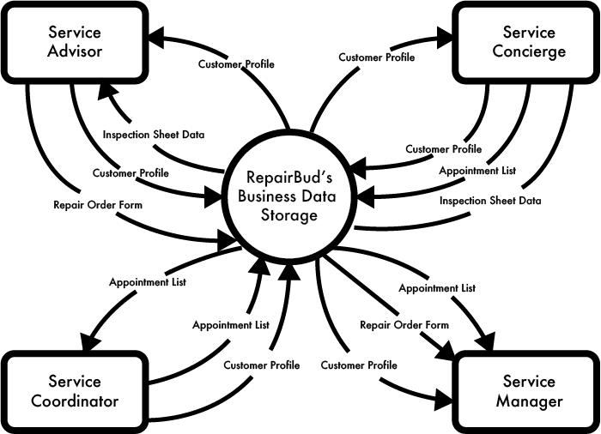

|  |  |
| --- | --- |
| **Requirement Scope Area** | **Description** |
| RepairBud Business Data Storage | Area responsible for storage of any customer documents and business process information (Customer profiles, Repair Order, Appointment Schedule) |

|  |  |
| --- | --- |
| **External Entity** | **Description** |
| Service Advisor | Service employee responsible for creating/editing and view customer repair orders and setting service status |
| Service Concierge | Service employee responsible for inputting/editing customer profiles and inspection sheet data |
| Service Coordinator | Service employee responsible for booking customer appointments and sending customer receipts based on customer preferences |
| Manager | Service Manager in responsible for monitoring all new entries to any business process |
|  |  |

| **Information Flows** | **Description** |
| --- | --- |
| Customer Profile | Digital profile of a customer which stores personal data (vehicle data, personal data, repair history, receipts) |
| Appointment List | Digital list of booked customer service appointments e.g from a range of present day appointments or broad scope of up to 3 months |
| Inspection Sheet Data | Digital form outlying the inspection sheet of an customers coming to check-in to be processed further and added to the customers profile |
| Repair Order Form | Digital document that stores Customers repair Transaction available for creating(opening)/Closing(finalizing) |
|  |  |
|  |  |

1. Requirements Scope Statements

|  |  |  |
| --- | --- | --- |
| **HLR#** | **Description** | **Priority**  **(H, M, L)** |
|  | Concierge must be able to check-in and bring up a customer’s profile for off the appointment list | H |
|  | Concierge must be able to inspect a customer’s vehicle via Photo, video or touch pad template | H |
|  | Concierge must be able to edit and add information to a customer’s profile such as mileage or new vehicles the customer owns | H |
| HLR04 | Concierge must be able to forward inspection sheets to advisor | H |
| HLR05 | Advisor must be able to create a new repair order based on the forwarded inspection sheet from the concierge | H |
| HLR06 | Advisor must be able to filter out scheduled appointments to only their clients booked with them | M |
| HLR07 | Advisor must be able to store repair orders and inspection information in the system under the customer profile the repair order was made for | H |
| HLR08 | Advisor must be able to view repair orders of specific customers | M |
| HLR09 | Advisors must be able to forward specific repair order to technicians devices | H |
| HLR10 | Advisor must be able to set a service status on a customer’s repair service | M |
| HLR11 | Coordinator must be able to log appointments based on customers preference and calendar availability | H |
| HLR12 | Users must be able to search up customers profile by VIN, Phone number, Name or Email under their profile | H |
| HLR13 | Coordinator Must be able to close repair orders that an Advisor sends over to them to finalize | M |
| HLR14 | Coordinator must be able to view scheduled appointment in specified internals e.g Today, Week, Month, 3 Months | M |
| HLR15 | Coordinator must be able to send customer receipts of request from customer | L |
| HLR16 | Manager Must be able to bring up and get notified when a new Repair Orders is created on demand | M |
| HLR17 | Manager Must be able to bring up and get notified when a new Appointment is created and added to the list on demand | M |
| HLR18 | Manager Must be able to bring up and get notified when a new Customers Profile is created and added to the list on demand | M |

1. High Level Business Requirements Sign-Off

The undersigned acknowledge their agreement with the contents of Version 1.0 of the High-Level Requirements document for RepairBud

Following approval of this document, requirements changes will be governed by the project’s change management process, including impact analysis and appropriate reviews and approvals, under the general control of the Project Plan and according to company policy. Approved Change Request Documents, if present, will be attached to this Requirements Document as updates.

|  |  |  |
| --- | --- | --- |
| **Name** | **Project Role and**  **Functional Area** | **Date Signed** |
| Patrick | Developer | September 29th 2019 |
| Aslm | Developer | September 29th 2019 |
| Ardm | Developer | September 29th 2019 |
| Elham | Developer | September 29th 2019 |

* Note: physical signatures are not required. Email approvals are acceptable and should be appended to project documents.